THE TRIANULAR SLAVE ROUTE
The triangular route starts in Great Britton, people got on a boat with copper, silk, glass, guns and much more to sail to Africa. When they get to Africa they traded these things with Africans. They trade them for SLAVES. Then they sail to America and trade the slaves for rum, sugar, rice, tobacco, coffee, and cotton They sail back to Great Britton and it happens over and over and over.
SLAVE SHIPS
At least 15 million Africans were taken to America between 1540 and 1850. To make as much money as possible the slave traders got as many people as possible into the boat. By 1800 slaves could be purchased in Africa for about $25 and sold in the Americas for about $150. The journey from Africa to the West Indies or North America Usually took about two months. The average amount of space for a slave is 7 feet. Many died because there were no bathrooms causing many diseases and deaths.

SOLD TO THE HIGHEST BIDDER
Before the bidding began people could come up onto the platform to inspect the blacks. The slaves had to put up with being poked, prodded and forced to open their mouths for the masters.
The auctioneer would decide a price to start the shouting. This would be higher prices for in shape, young slaves and lower for older, very young, or sick slaves. The person who bid the most would then own that slave. The picture here shows a slave being auctioned to the highest bidder.

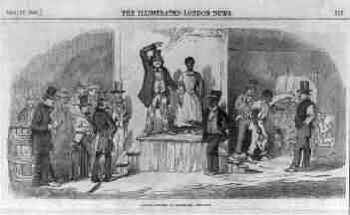

THE GRAB AND GO AUCTION
All people who wanted to buy a slave on the day of the auction would pay the trader an agreed amount of money. Then the trader would give them a ticket for each slave that they had bought. At the sound of a drum roll, the door to the slave pen would be opened and the buyers would rush in and grab the slave or slaves that they wanted. The buyers then checked their slaves out by giving their ticket to the slave trader
HOW SLAVES WERE TREATED
The lives of slaves were hard. All they got was a place to sleep, clothing, enough food to keep them healthy enough for work. They worked six or seven days a week, for most of the daylight hours. Slaves were worked as hard as a body can. Many slaves died from whippings and other unreasonable punishments
PUNISHMENTS
The normal punishments of slaves for not doing work, eating the sugar cane, and theft, are whipping, beating with a stick, sometimes breaking bones, the chain, an iron crook about the neck, a ring about the ankle There have been slitting of ears, breaking of limbs to make amputation needed, and beating out people’s eyes. One word to describe punishments of this type is unreasonable.

